September 2018 quarter
Consumer Price Index of Tokelau

Key facts
In the September 2018 quarter compared with the June 2018 quarter:
- The consumer price index (CPI) rose 4.2 percent.
- The largest upward change in prices this quarter is by the Alcoholic beverages and tobacco group which rose 12.1 percent, contributing 3.7 percent to CPI.
- The Food and non-alcoholic beverages group prices rose 5.5 percent, contributing 1.8 percent to CPI.
- The largest downward change in prices came from the Transport group, down 14.2 percent, contributing negative 1.0 percent to CPI.
From the September 2017 quarter to the September 2018 quarter, CPI increased 4.8 percent. This compares with a 6.6 percent increase in the June 2017 quarter to the June 2018 quarter.
The CPI measures the rate of price change of goods and services purchased by Tokelau households. The Tokelau National Statistics Office (TNSO) collects prices from the co-op and bulk stores on all three atolls, as well as prices from service providers, including transport, energy, and telecommunications.
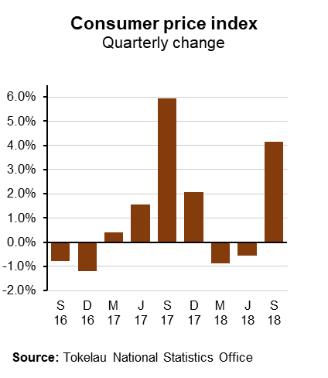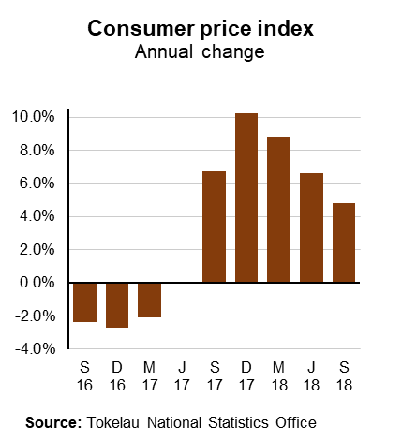

for National Statistician 31 October 2018

Commentary
The following sections provide detailed commentary on the consumer price index of Tokelau:
- Quarterly CPI increase of 4.2 percent for September 2018
- Alcoholic beverages and tobacco group up this quarter
- Summary of other group movements in the quarterly CPI
- Impact of items that rose and fell in price
- CPI shows 4.8 percent increase for the year to the September 2018 quarter
- Rebase of March 2017 quarter now fully implemented
- Definitions.

Quarterly CPI increase of 4.2 percent for September 2018
The September 2018 CPI rose by 4.2 percent. By contrast, quarterly inflation was negative 0.5 percent in the June 2018 quarter.
Two of the CPI’s nine groups recorded price increases for the September 2018 quarter, three groups recorded price decreases and four remained unchanged.
Prices in the Food and non-alcoholic beverages group increased 5.5 percent, contributing a positive 1.8 percent to quarterly CPI.
The main individual upward contributions to the food subgroup came from higher prices for:
- Rice (up 38 percent)
- Chicken (up 11 percent)
- Longlife milk (up 10 percent).
The main individual downward contributions to the food subgroup came from lower prices for:
- Cheese-flavoured corn snacks (down 46 percent)
- Potatoes (down 14 percent)
- Cabbages (down 32 percent).
Group | Quarterly percentage points contribution to CPI
01. Food and non-alcoholic beverages |  | 1.8
02. Alcoholic beverages and tobacco |  | 3.7
03. Clothing and footwear |  | 0.0
04. Housing, water, electricity, gas and other fuels |  | -0.2
05. Furnishings, household equipment and routine household maintenance |  | 0.0
07. Transport |  | -1.0
08. Communication |  | 0.0
09. Recreation and culture |  | -0.1
12. Miscellaneous goods and services |  | 0.0
Overall CPI |  | 4.2
Note: Percentages may not sum to total due to rounding.

Alcoholic beverages and tobacco group up this quarter
Prices in the Alcoholic beverages and tobacco group went up 12.1 percent, contributing 3.7 percent to CPI this quarter. This increase is due entirely to a 17 percent increase in prices for cigarettes in Fakaofo, implemented by the Taupulega (village council) to further discourage smoking. This increase compares to a negligible contribution to CPI in the June 2018 quarter.

For the September 2018 quarter compared to the same period in the previous year, Alcoholic beverages and tobacco prices increased by 20 percent, contributing 5.7 percent to the annual inflation rate of 4.8 percent.
Summary of other group movements in the quarterly CPI
The Transport group showed price decreases of 14 percent, contributing a negative 1.0 percent to CPI. The Recreation and culture group showed prices dropping by 5.4 percent, contributing a negative 0.1 percent to CPI. Prices in the Housing, water, electricity, gas and other fuels group decreased 2.3 percent, contributing a negative 0.2 percent to quarterly inflation.
Two other groups showed small changes this quarter: Clothing and footwear (up 1.0 percent) and Miscellaneous goods and services (down 0.1 percent); their contribution to CPI was negligible. Furnishing, household equipment and routine household maintenance; and the Communication group remained unchanged.

Impact of items that rose and fell in price
The graph below shows the impact of items that rose and fell in price over time: the overall impact was a 4.2 percent increase in CPI for the September 2018 quarter.
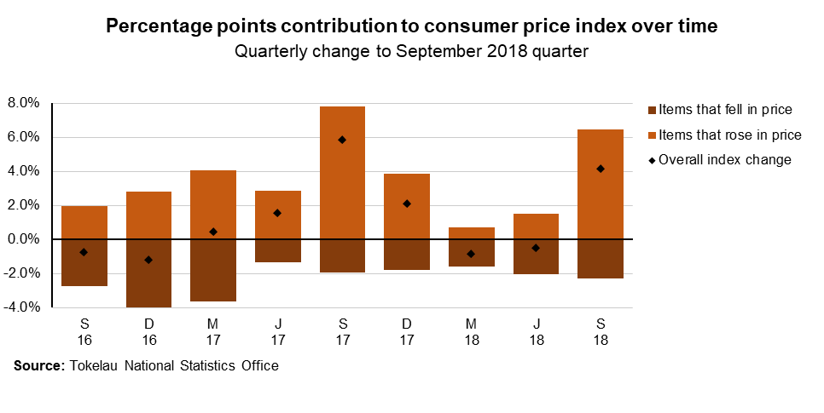

The following graph shows the impact of items that rose and fell in price by group this quarter:
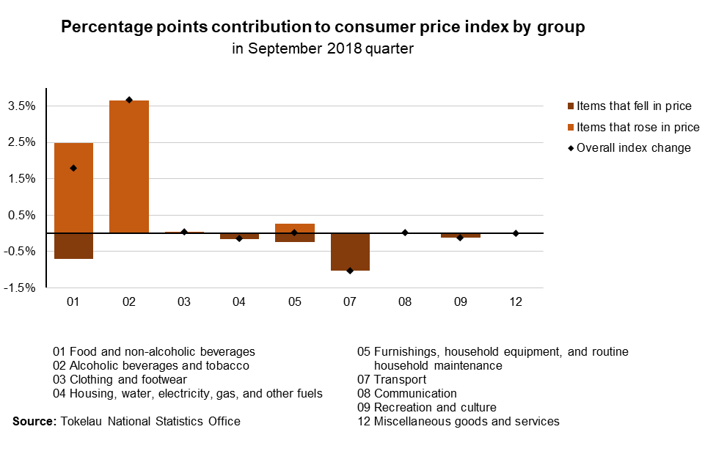

CPI shows 4.8 percent increase for the year to the September 2018 quarter
The CPI increased 4.8 percent in the year to the September 2018 quarter. This compares with a 6.6 percent annual inflation rate in the June 2018 quarter.
The main upward movement came from the group Alcoholic beverages and tobacco, up 20 percent, due mainly to the national tobacco pricing policy in 2017 (contributing 5.7 percent to annual CPI). Prices in the group Furnishings, household equipment, routine household maintenance rose 2.6 percent, contributing 0.2 percent to annual CPI. Prices in the group Food and non-alcoholic beverages rose 1.4 percent, contributing 0.5 percent to annual CPI.

Key individual upward contributions to the Food subgroup came from higher prices for:
- Rice (up 31 percent)
- Chicken (up 7 percent)
- Longlife milk (up 12 percent).
The main individual downward contributions to the Food subgroup came from lower prices for:
- Canned tuna (down 27 percent)
- Flour (down 22 percent)
- Lamb chops (down 12 percent).
Prices in the Transport group fell 12.6 percent, contributing a negative 0.9 percent to annual inflation. Since the re-base in the March 2017 quarter, we were able to report on the Recreation and culture group for the first time for previous quarters (March and June 2018: down 9.9 and 10 percent, respectively). For the year to the September 2018 quarter, this group fell 11 percent, contributing a negative 0.3 percent to the annual change in CPI. Prices in the Miscellaneous goods and services group went down 2.8 percent, contributing negative 0.1 percent.

Other contributions to annual CPI were minor, including the Clothing and footwear group (prices down 1.5 percent, contributing negative 0.1 to annual CPI); and the Housing, water, electricity, gas and other fuels group (prices down 2.3 percent, contributing negative 0.2 percent to annual CPI). The Communication group did not change.

Rebase of March 2017 quarter now fully implemented

The Tokelau CPI was rebased in the March 2017 quarter, mainly founded on data from the 2015/16 Household income and Expenditure Survey (HIES). Although the basket of goods and services was adjusted accordingly then, it was decided at the time to publish CPI continuously from base quarter June 2012 (=1.000).

Upon further consideration we are now presenting data from base quarter March 2017 (=100.0), see graph below. The tables accompanying this release provide all data referenced to that quarter; in the next release we will continue the usual series of current and four preceding quarters.

We will continue to separate out the effect of cigarette pricing policy, as Tokelau aims to be smoke-free in 2020. Adjustments to the weighting of cigarettes (currently 16.16%) will be attempted as information comes to hand about the effectiveness of this policy: it should reduce cigarette purchases in the co-op stores of the villages, and hence their weighting in CPI to nil eventually, as in-store sales cease.

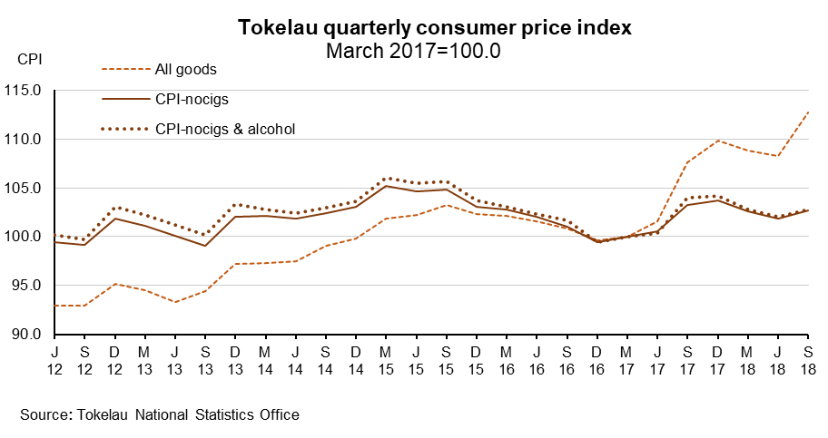

Definitions
About the consumer price index
The consumer price index (CPI) measures the changing price of a fixed basket of goods and services purchased by households. The selection and relative importance of the goods and services in the CPI basket represents the overall expenditure pattern of households in Tokelau.
The aim of the CPI is to measure price changes of the same sample of products at each outlet over time. When there is a change in the size or quality of any of the goods or services in the basket, an adjustment is made to ensure that the price change shown in the CPI is not affected by the change in size or quality.
The CPI of Tokelau has been published quarterly since September 2012, and was rebased in the March 2017 quarter (=100.0).
An updated listing of the representative goods and services monitored in the CPI basket, and the sources and methods used to compile various parts of the CPI, are available in the “Technical notes: Consumer Price Index” (October 2017 version) at www.tokelau.org.nz/Stats.html.
More definitions
A price index measures the change in price between time periods for a given set of goods and services. It summarises a set of prices for a variety of goods and services collected from a number of outlets.
The index reference period is the benchmark to which prices in other periods are compared (eg if the index number in a later period is 115.0, prices have increased by 15.0 percent since the index reference period).
Upward/downward contributions: Items mentioned in this release are often those that made a large contribution to the overall movement in the CPI. An item's contribution is a combination of its weight in the index (its relative importance, based on its share of household spending on goods and services covered by the CPI) and the magnitude of price movement. If two items record the same percentage rise in price, then the item with the larger CPI weighting will make a larger contribution to the overall movement. This contribution is also referred to as points (or index points) contribution.
Reference period and data quality
Prices for the September 2018 quarter were collected between 15 August and 12 September 2018, by staff working for the nuku administrative centres, as well as TNSO staff in Apia. Fewer items were out of stock so fewer prices had to be imputed, which may partly explain the relatively steep CPI this quarter (which may have been cumulative for imputed items).
Price influencers
Price changes may be influenced by external events. Factors that affected the quarterly and the annual September 2018 CPI include:
- Tokelau uses the New Zealand dollar as its currency, so major changes in the strength of the New Zealand dollar over the Samoan tala can change Tokelau’s buying power in Samoa., The Tokelau Department of Finance tends to fix its exchange rate for the calendar year (currently WST/NZD=1.75), taking out some of the volatility.
- Since 2013 nearly all goods sold in Tokelau have been sourced directly from Samoa. Many of these goods are re-exports, originating from various other countries including China, Australia, and New Zealand. This introduces price fluctuation between quarters, and can be caused both by local demand, and by international variables including demand, availability, seasonal effect, and changes in exchange rates. Changes in availability or price in Samoa have a strong influence on the Tokelau CPI.
- Each nuku sets pricing policy (such as for meats, alcoholic and non-alcoholic drinks) independently, and this can change at any point. In July 2017, General Fono (Parliament) approved a national 325 percent tax increase on cigarettes, in an effort to reduce smoking and hence the prevalence of non-communicable diseases in the atoll population. In July 2018, a further price rise of NZ$4.50 per packet of 20 sticks was implemented by the Taupulega in Fakaofo. Because cigarettes have a relatively large weight in the CPI, any change in their price will significantly impact the overall CPI movement, as was seen throughout 2017.

Liability
All care and diligence has been used in processing, analysing, and extracting data and information in this publication. However, the TNSO gives no warranty it is error-free and will not be liable for any loss or damage suffered by the use directly, or indirectly, of the information in this publication.

Timing
Our information releases are delivered electronically by third parties. Delivery may be delayed by circumstances outside our control. The TNSO does not accept responsibility for any such delay.
[ends]

